VacTrack

Feature Description Document

# Table of Contents

**Revision History……………………………………………………………………………………..3**

**Introduction****………………………………………………………………………………………..…****4**

**Features****……………………………………………………………………………………………....****5**

**Home****……………………………………………………………………………………………...****5**

**About Us****……………………………………………………………………………………….…****6**

**Help****………………………………………………………………………………………………..****6**

**Sign Up****…………………………………………………………………………………………...****7**

**Sign in****………………………………………………………………………………………….....****7**

**Dashboard****………………………………………………………………………………………..****8**

**Add Dependent****…………………………………………………………………………..…****9**

**Add Vaccines****…………………………………………………………………………...****9**

**Admin Panel****……………………………………………………………………………………****10**

**Login Screen****……………………………………………………………………………….****10**

**Home screen****……………………………………………………………………………….****10**

# Revision History

|  |  |  |  |
| --- | --- | --- | --- |
| **#** | **Revision** | **Author** | **Description** |
| 1 | 2021/09/27 | Pardeep | Initial Draft |
|  |  |  |  |

# 

# 

# Introduction

VacTrack is an initiative to facilitate effective communication between doctors and parents by keeping track of vaccination schedules for children and easily access reports at one place. It provides a platform where doctors can schedule vaccines for the children and notify the parent.

# Features

User can be doctor or parent. The user once hits the application in the browser. He’ll have the following options.

1. Home
2. About Us
3. Help
4. Sign in

Once a user signs in. there will be different options available for an authenticated user according to the rights.

1. Add dependents
2. View dependents
3. Schedule any vaccination for a user.
4. Update vaccination schedule.
5. Update self profile or dependents profile.

## **Home**

Home is the first page that gets displayed when a user opens the application in the browser. It shows the motive of the application. There’s a read more button which will open a new page with detailed motive of the application.

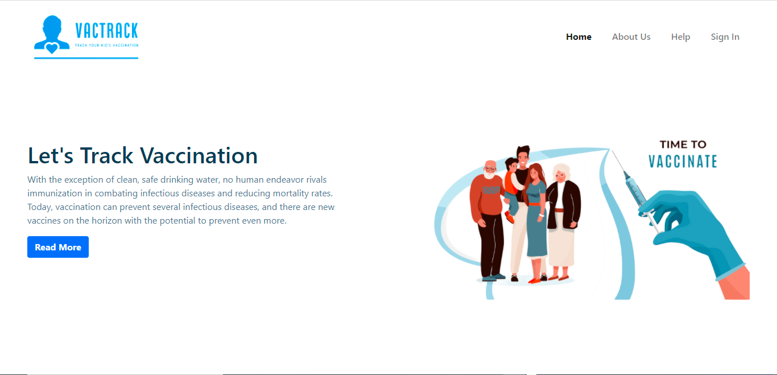

## About Us

In this section, users can have a detailed explanation of who we are. What is our motive? How do we want to help society?

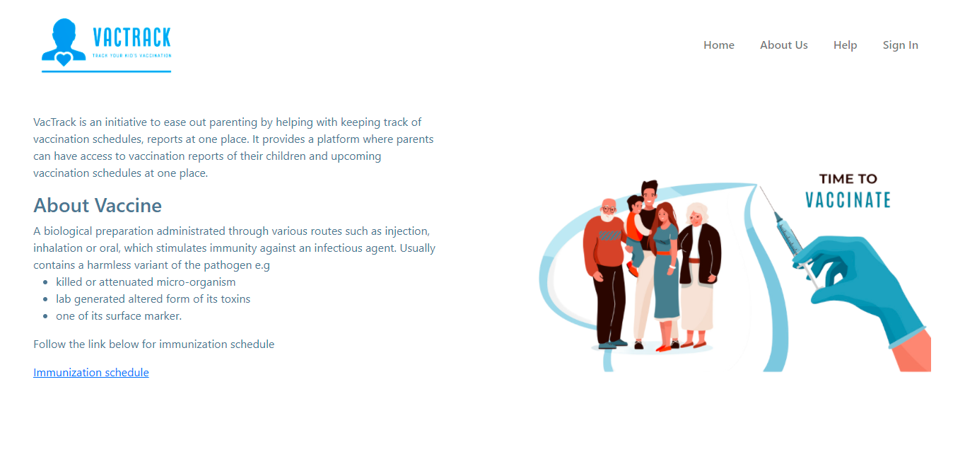

## Help

It may include a guide, how we can use this application. Currently it has not been decided what to include here.



## Sign in

This is common page where the users can signup and signin themselves on the application. Once a user has registered him/her successfully. He can sign in to the application using this screen itself.

Once a user signs in he’ll get a message signing in failed or he’ll redirect to dashboard.

Signup and signin is done using OTP.

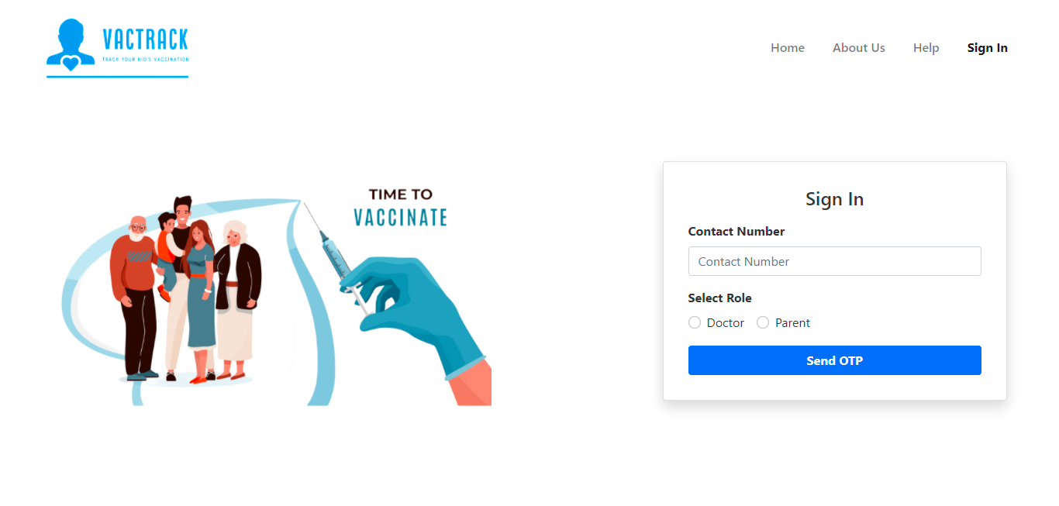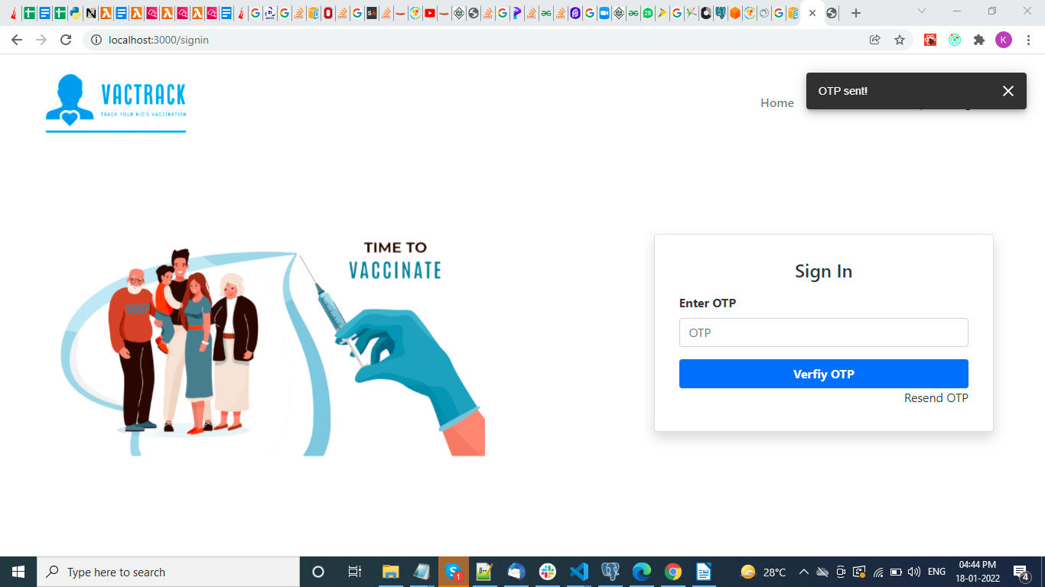

## Dashboard

On successfully login, the user will be redirected to the dashboard. Users have below abilities here.

* View and update profile for any dependent
* View and update vaccination schedule for any dependent
* Add a dependent
* Schedule vaccination for a dependent

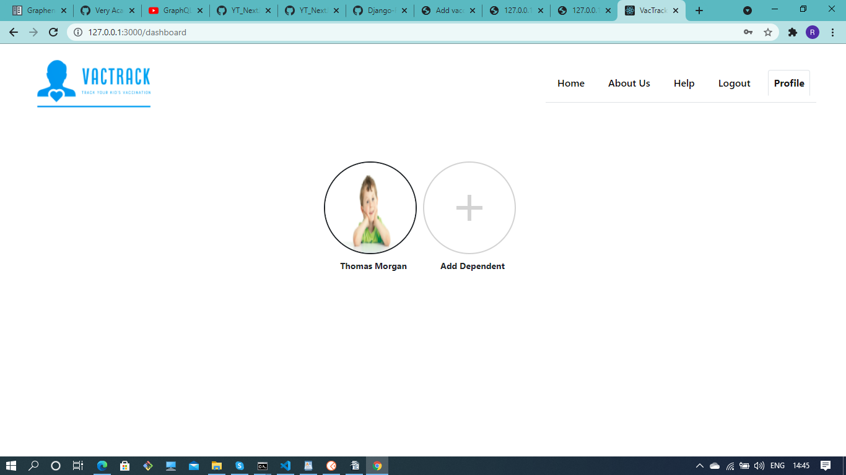

### 

### Add Dependent

When a user clicks on add dependent option, he can add a new dependent by entering below information:

* First Name
* Last Name
* DOB
* Blood Group
* Gender

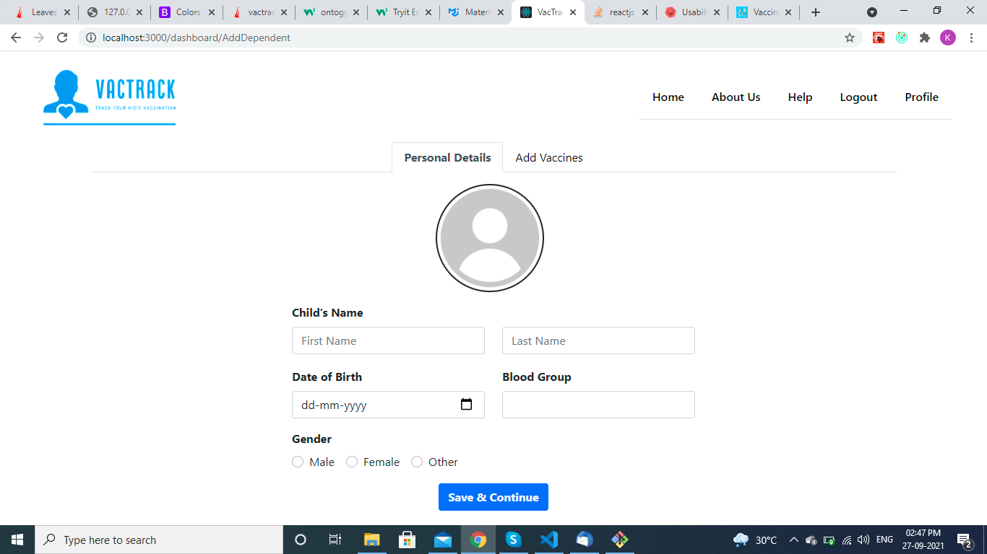

After adding dependent, users can schedule vaccination at the same time for the dependent by switching the tab to add vaccines.

#### Add Vaccines

Here, the different categories will be shown for vaccines.User can schedule vaccination for the dependent from the available categories.

Categories included are:

* For Pregnant Women
* At Birth
* At 6-14 weeks
* At 9-12 weeks
* For Children
* For Others

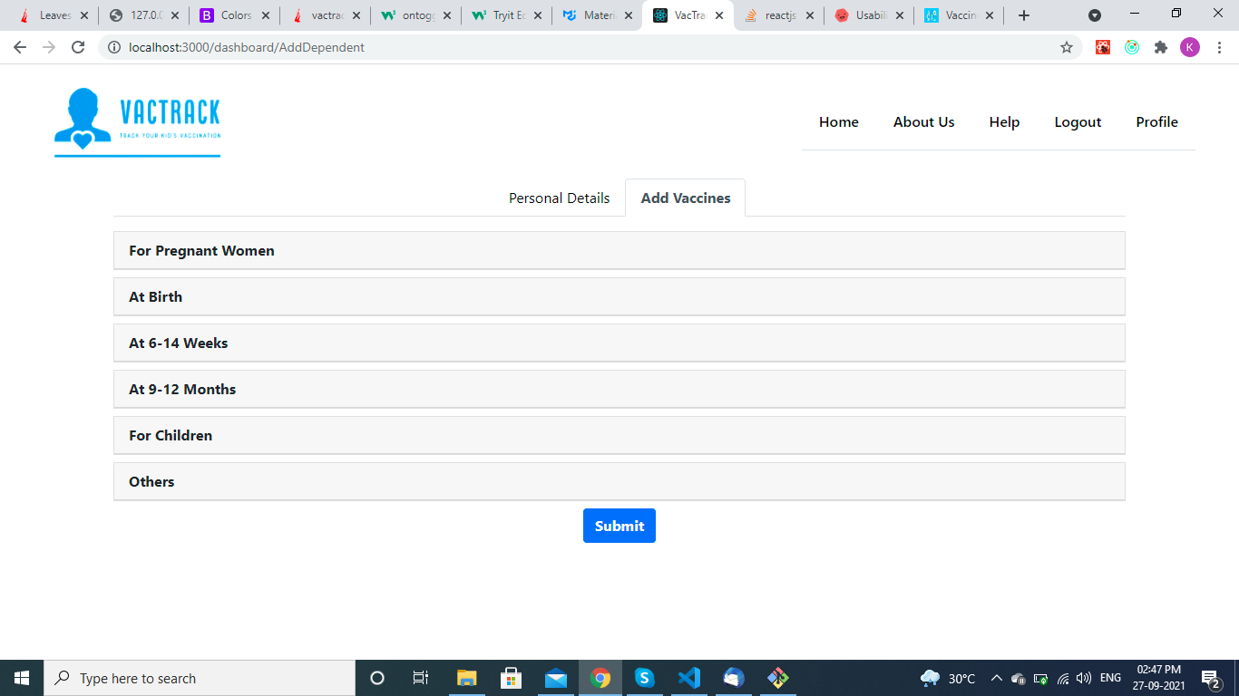

## **Admin Panel**

Those users who have admin access to the site can login to the Admin portal and can perform CRUD operations on different entities.

### Login Screen

Admins can login using this screen with their email and password.

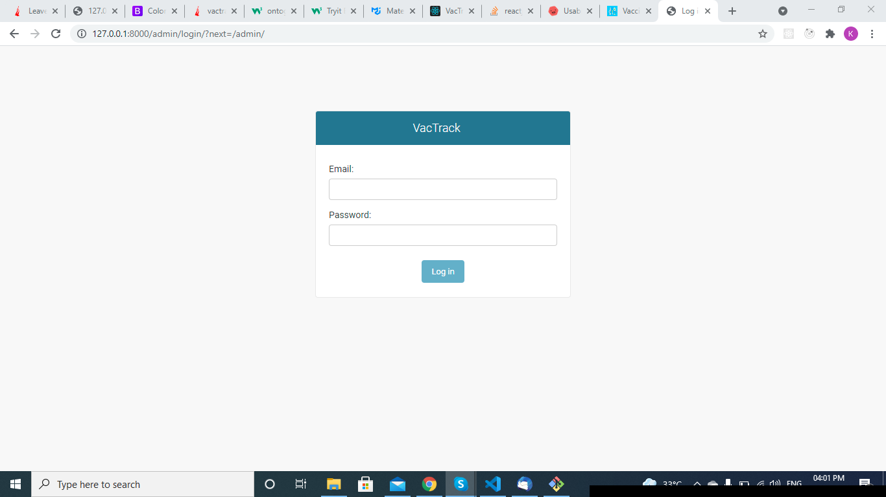

Admin Login screen

### Home screen

Once an admin login, he can see different entities here. Admin can also see the recent actions (update/delete) that he has performed through this admin portal.

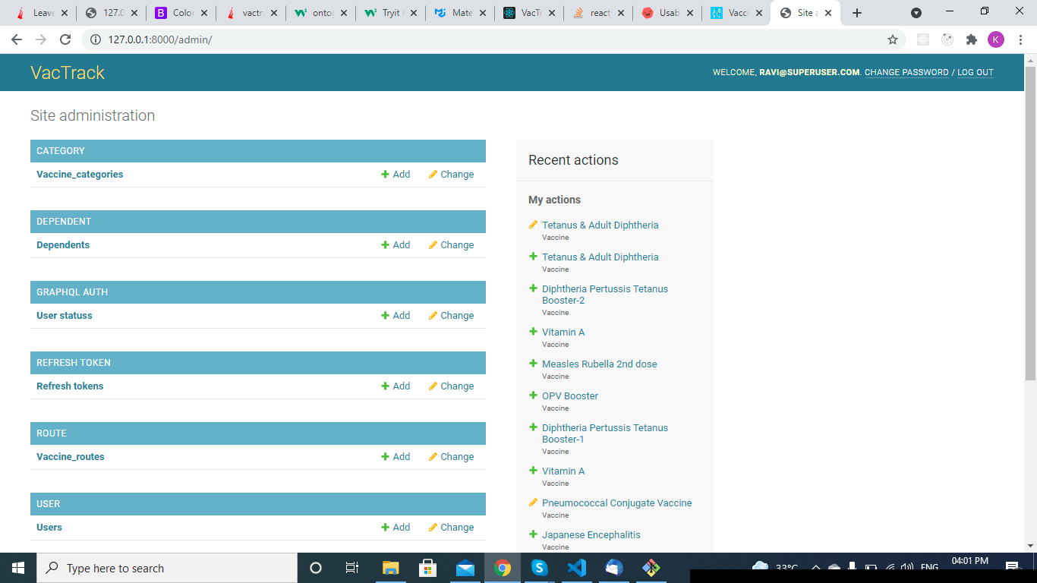

Admin Home screen

Users can add/change/delete/view the different entities here.